http://www.boston.com/bostonglobe/ideas/articles/2008/05/04/where_do_all_the_neurotics_live/#

Where do all the neurotics live?

On the East Coast, of course. A psychological tour of the United States, in five maps.
(Jason Rentfrow, Cambridge University; Kevin Stolarick, University of Toronto, Original maps by Ryan Morris)
By Richard Florida
May 4, 2008
WE ARE ALL familiar with the rough geography of the United States - the slash of the Rocky Mountains between two great coastlines, the bulge of Maine, the Florida peninsula, the Great Lakes, set in the heartland.
But what about the country's psychogeography? You know, the great river of extroversion that flows roughly southeast from greater Chicago to southern Florida? Or the vast lakes of agreeableness and conscientiousness that pool together in the Sun Belt, especially around Atlanta? Or the jagged peaks of neuroticism in Boston and New York?
It's time to learn.
Psychologists have shown that human personalities can be classified along five key dimensions:
- agreeableness,
- conscientiousness,
- extroversion,
- neuroticism, and
- openness to experience.
And each of these dimensions has been found to affect key life outcomes from life expectancy and divorce to political ideology, job choices and performance, and innovation and creativity.
What's more, it turns out these personality types are not spread evenly across the country. They cluster. And how they cluster tells us much: What city someone might want to move to, the broader character of regions, and even the creative and economic futures of broad swaths of the nation.
Drawing on a database of hundreds of thousands of individual personality surveys compiled by psychologists Jason Rentfrow, Sam Gosling, and Jeff Porter, my team and I were able to map the distribution of personality types across the United States. The result is a fascinating new way of looking at the country's terrain.
Interestingly, America's psychogeography lines up reasonably well with its economic geography. Greater Chicago is a center for extroverts and also a leading center for sales professionals. The Midwest, long a center for the manufacturing industry, has a prevalence of conscientious types who work well in a structured, rule-driven environment. The South, and particularly the I-75 corridor, where so much Japanese and German car manufacturing is located, is dominated by agreeable and conscientious types who are both dutiful and work well in teams.
The Northeast corridor, including Greater Boston, as well as San Francisco, Los Angeles, Seattle, and Austin, are home to concentrations of open-to-experience types who are drawn to creative endeavor, innovation, and entrepreneurial start-up companies. While it is hard to identify which came first - was it an initial concentration of personality types that drew industry, or the industry which attracted the personalities? - the overlay is clear.
Understanding regional personality types can add to our understanding of what makes regional development tick. Economists argue that technology (in the form of great universities and high-tech company clusters) and human capital (talented people) drive economic growth. But psychologists would add that in addition to skills, talent, motivation, and resources, there are personality traits and psychological capital that predispose people toward certain talents and proclivities. For example, highly conscientious people have a disposition to be detail oriented, plan ahead, and stay organized. Openness to experience shapes people's ability to be creative, acquire new skills quickly, undertake new discoveries and innovations, and start new companies.
So regions like Silicon Valley or the high-tech Route 128 corridor around Boston succeed not just because they have great universities and highly educated people (some of the greatest high-tech entrepreneurs of our time are college dropouts), but also because they are magnets for highly ambitious, highly curious, and highly open personalities.
While opposites sometimes really do attract, and it is possible to make unusual matches work, our research indicates that people are typically happier in places with higher concentrations of personality types like their own.
But what accounts for such psychogeographical clustering? One potential explanation is that people migrate to places where their psychological needs are easily met: Open people choose to live in places with hustle and bustle to satisfy that craving for new experiences, while conscientious people settle in places where the atmosphere is ordered to meet their need for predictability.
Or perhaps, personality is influenced by our surroundings. More emotionally stable people who live in places where neurotic types form the majority may become irritable and stressed because the people around them are getting to them.
Our research suggests another possibility as well: the link between personality and the willingness to move. Conscientious and agreeable types in particular are less likely to move. Once they find a place, they tend to spread out gradually over time. Extroverts, on the other hand, are much more likely to move over greater distances. Open-to-experience types are drawn to thrills and risk, and moving, after all, is one of life's biggest new experiences.
This fuels a process of selective migration whereby agreeable and conscientious regions are drained of the most driven, most creative, and most mobile - only reinforcing their psychogeographic profiles, while magnifying the innovative edge in places where open-to-experience types concentrate.
Our evolving psychogeography means that our nation, its people, and its regions continue to sort themselves not just by education and skill, but by personality as well.
Richard Florida is the author of "Who's Your City?" and director of the Martin Prosperity Institute at the University of Toronto's Rotman School of Management.
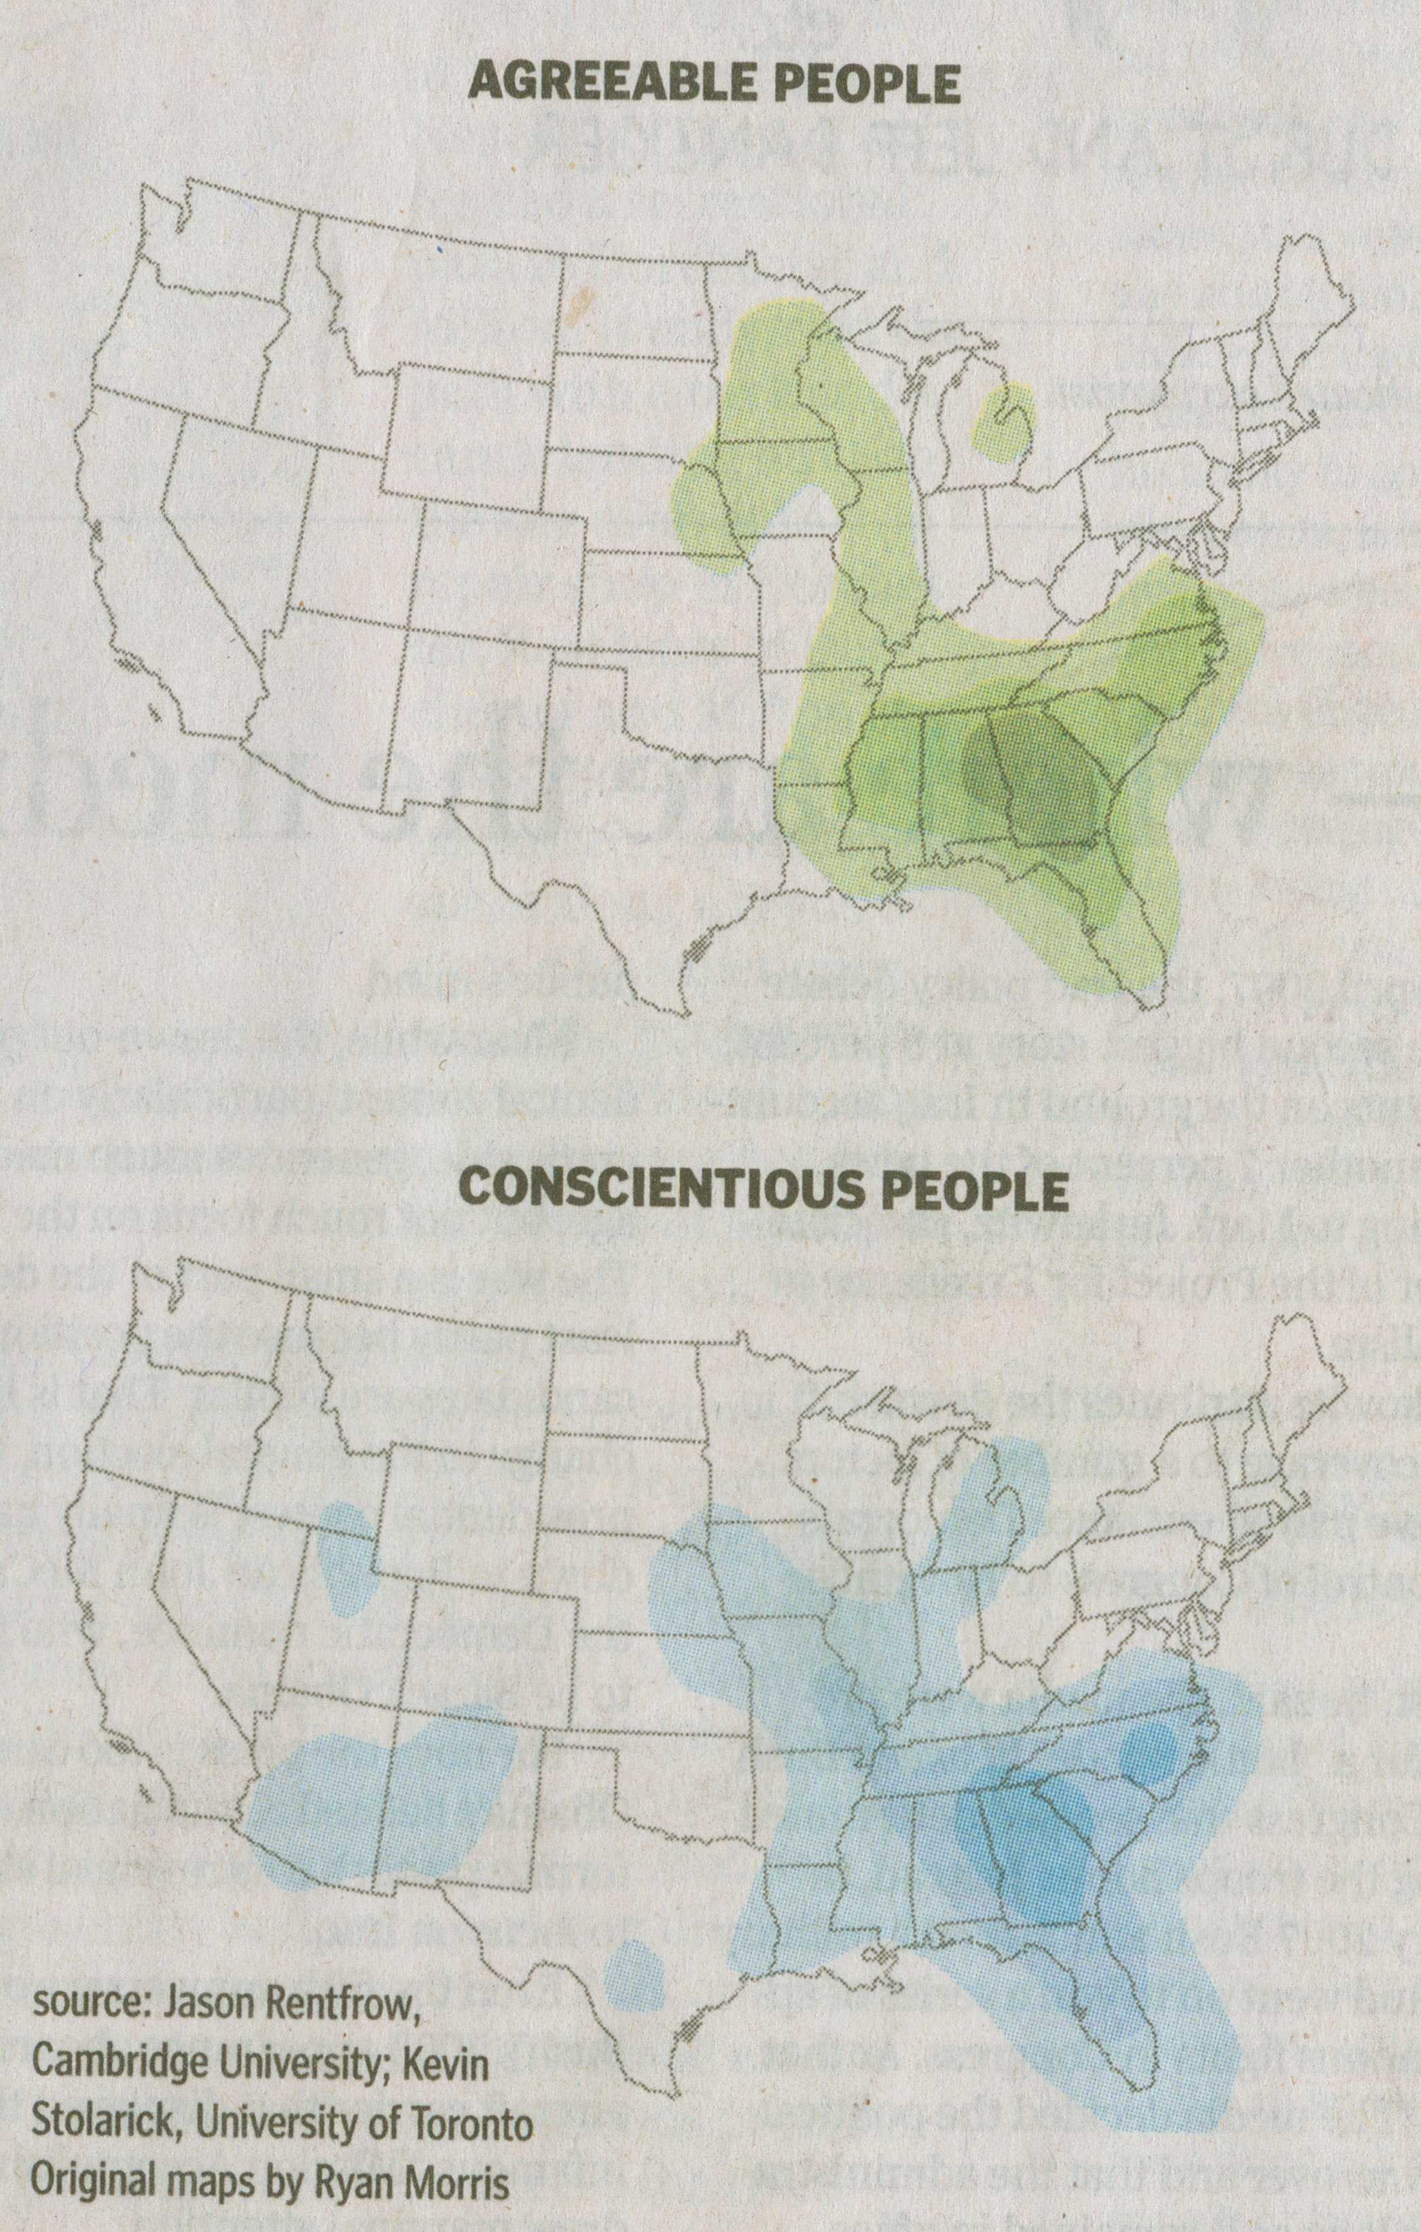
Agreeableness, Conscientiousness
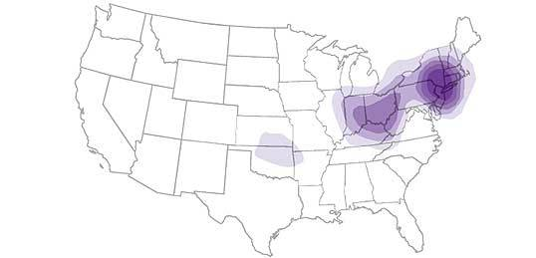
Neuroticism
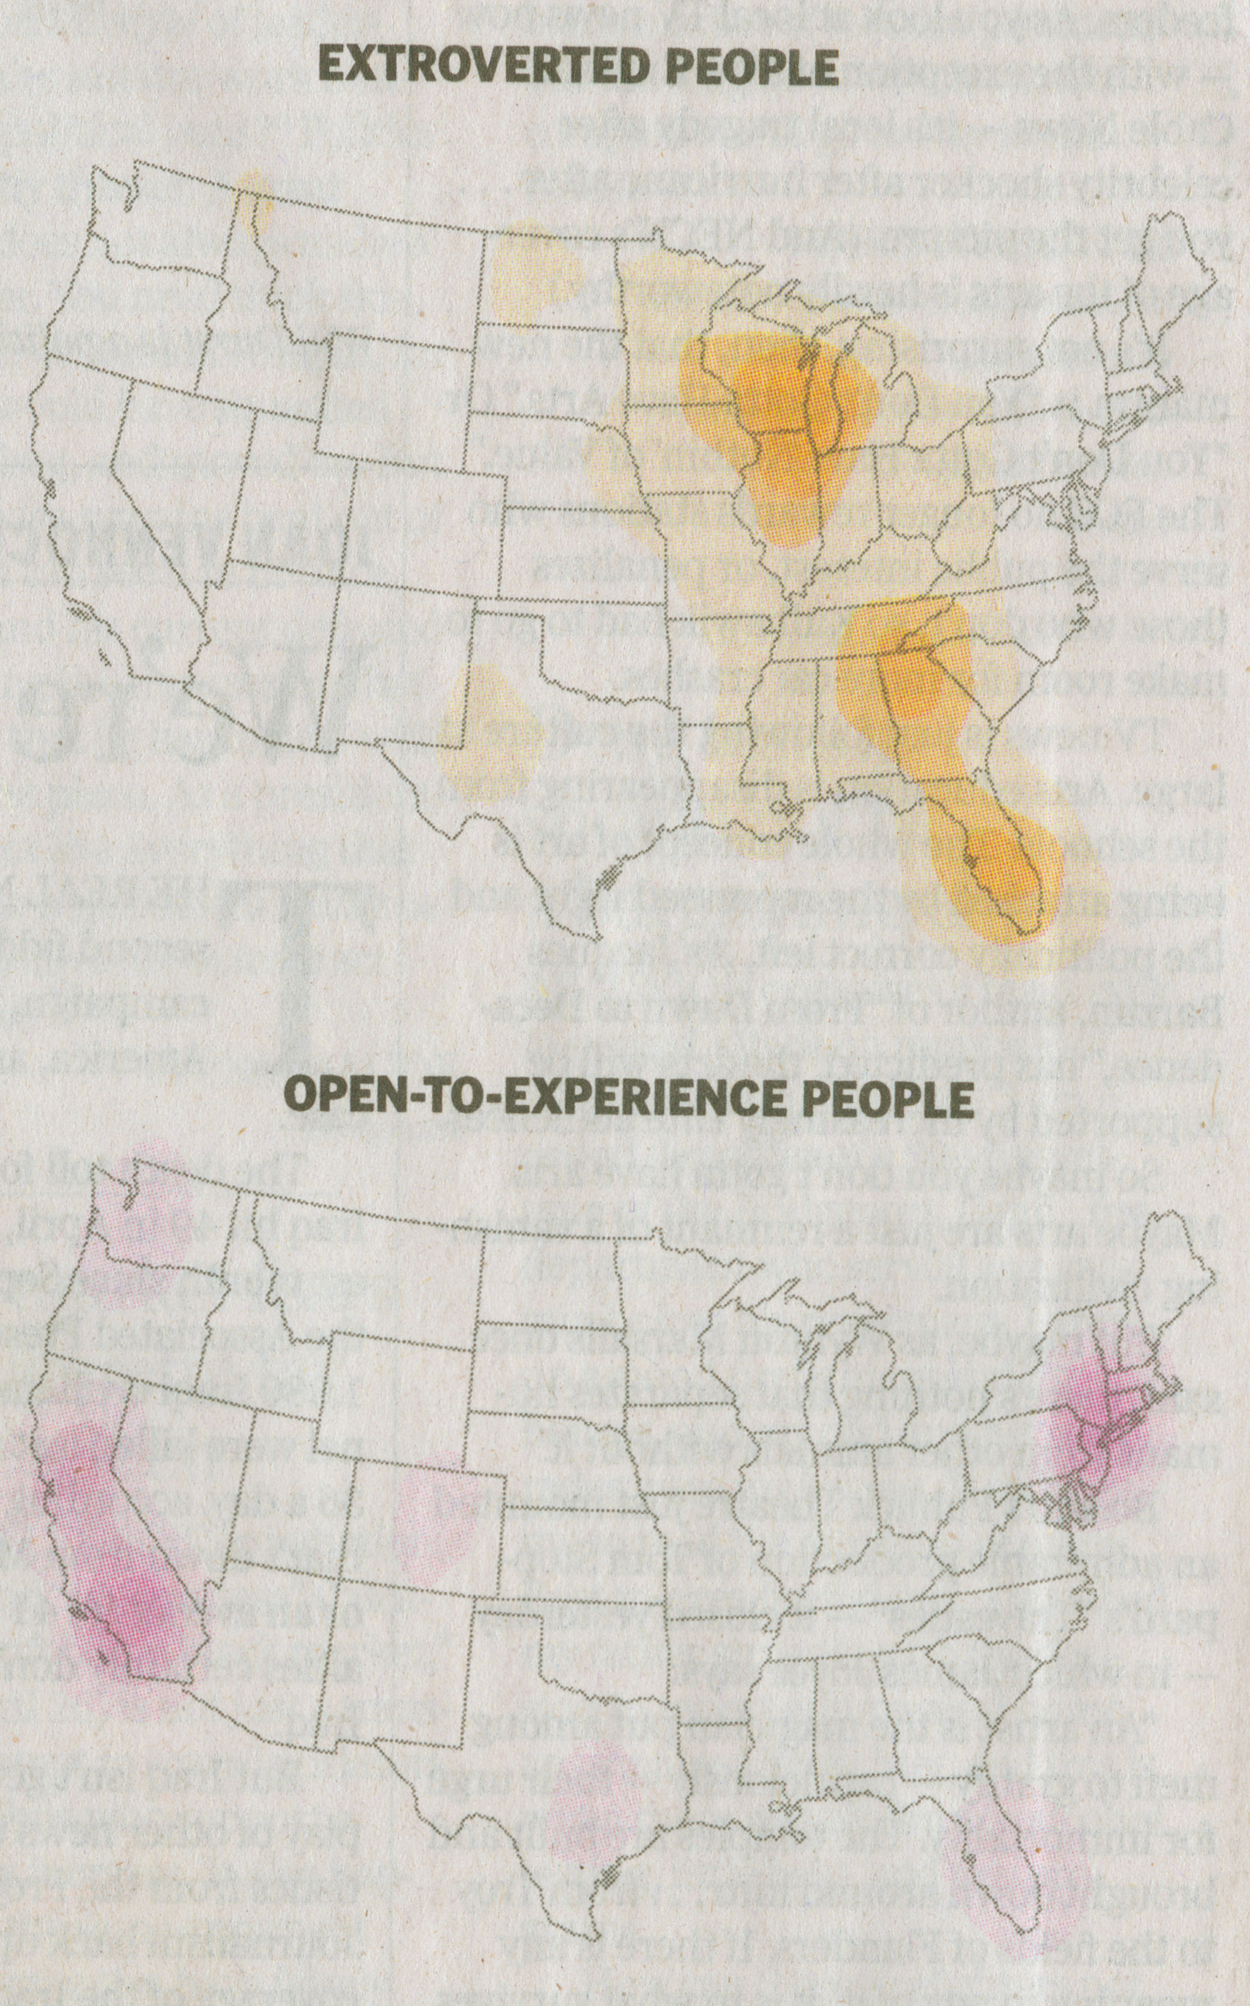
Extroversion, Openness to Experience

